High-throughput computational dynamic mechanical analysis with DMAx

Ricardo Silva Buarque^{1,2}, Beneen Fune³, Sasawat Jamnuch^{3,4} and Tod A Pascal^{1,2,3*}

¹Program in Material Science and Engineering, University of California San Diego, San Diego, CA, 92093, United States of America
²Sustainable Power and Energy Center, University of California San Diego, San Diego, CA, 92093, United States of America
³Aiiso Family Department of Chemical and NanoEngineering, University of California San Diego, San Diego, CA, 92093, United States of America
⁴Microscopy and Microanalysis Research Group, National Institute of Standards and Technology, Gaithersburg, MD, 20899, United States of America
*corresponding author: tpascal@ucsd.edu

Abstract
Dynamic Mechanical Analysis (DMA) is a foundational technique for characterizing the viscoelastic behavior of soft materials such as polymers and microporous frameworks. In this work, we introduce DMAx, a high-throughput computational framework that integrates atomistic molecular dynamics (MD) simulations to predict mechanical properties across a significantly broader frequency and temperature range than conventional experiments allow. DMAx automates the optimization of critical simulation parameters—such as runtime and strain amplitude—to ensure accuracy and reproducibility. We validate the workflow using an amorphous poly(vinylidene fluoride) (PVDF) system modeled with the OPLS-AA force field. By applying the time–temperature superposition (TTS) principle, DMAx generates storage and loss moduli that align well with experimental data. These results demonstrate DMAx’s potential as a scalable and predictive tool for viscoelastic analysis, enabling rapid screening of polymeric materials for applications in soft robotics, acoustic manipulation, and high-frequency signal processing.

Introduction
The study of material behavior under dynamic conditions is paramount across a broad spectrum of scientific and engineering disciplines. Understanding and manipulating the intricate mechanical properties of polymers, membranes, and porous frameworks, subjected to varying temperature, frequency, and strain rates, is critical for scientific advancement.¹ One way of quantifying these behaviors is through Dynamic Mechanical Analysis (DMA): a powerful and versatile tool that offers valuable insights into the viscoelastic and mechanical behavior of materials over a wide range of conditions. Experimentally, DMA is performed using a Dynamic Mechanical Analyzer or Rheometer and consists of applying a small periodic stress to the sample with a defined frequency and under controlled temperature conditions. The oscillatory stress, in turn, generates a strain response at the same frequency, although the nature of this response is material-dependent. Thus, in a perfectly elastic material, the sinusoidal stress perfectly matches the applied strain, while in a perfectly viscous material, the response is offset in phase angle by 90°. All other viscoelastic materials display a phase lag in their stress response between 0° and 90°.²
DMA provides access to key viscoelastic parameters that characterize material response under oscillatory deformation. Among these, the storage modulus (SM), loss modulus (LM), and loss tangent (LT) serve as principal metrics for quantifying elastic energy storage, viscous dissipation, and damping behavior, respectively. These quantities are derived by evaluating the ratio of peak stress (σₘₐₓ) to peak strain (εₘₐₓ), modulated by a trigonometric function of the phase angle (θ) that delineates the lag between stress and strain waveforms, as seen in Equation 1.

$SM=\frac{σ_{max}}{ε_{max}}\cos{θ}$ (1.1)
$LM=\frac{σ_{max}}{ε_{max}}\sin{θ}$ (1.2)
$LT=\frac{LM}{SM}=\tan{θ}$ (1.3)
The storage modulus reflects the elastic component of a material’s viscoelastic behavior, quantifying its ability to store mechanical energy during cyclic deformation and serving as a measure of intrinsic stiffness.³ This parameter exhibits a notable dependence on the frequency of the applied load, often increasing with higher deformation rates. In contrast, the loss modulus captures the viscous response, delineating the fraction of mechanical energy dissipated as heat and characterizing the material’s damping capacity. Both moduli demonstrate sensitivity to variations in frequency and temperature, underscoring the dynamic nature of viscoelastic materials. The loss tangent, defined as the ratio of the loss modulus to the storage modulus, provides a dimensionless metric of energy dissipation relative to energy storage, thereby offering key insights into a material’s damping performance. By evaluating these moduli across differing time scales, temperatures, and loading frequencies, one can probe essential phenomena such as viscoelasticity, glass transition, molecular relaxation, and energy dissipation. The breadth of information revealed through such analyses underscores the appeal of DMA for comprehensive mechanical characterization. Nevertheless, several experimental challenges persist, particularly regarding sensitivity, reproducibility, and the accurate interpretation of complex material responses.
One challenge arises from the instrument’s inertia: the energy required to overcome it during oscillatory loading can be inadvertently transferred to the sample as latent heat, complicating efforts to maintain thermal stability. To mitigate this, samples are typically housed within a heat-controlled chamber during DMA; however, the operational temperature range of these chambers is often restricted, making it difficult to regulate temperature under high-frequency stress conditions, particularly for viscous materials.⁴ Dimensional inaccuracies in sample preparation—commonly on the order of micrometers in rheometric setups—further compromise measurement fidelity, given the geometry-sensitive nature of viscoelastic property determination. These factors, compounded by the mechanical actuation limits of rheometers, confine the reliable perturbation frequency of most DMA systems to approximately 1 kHz.⁵ Consequently, high-frequency mechanical characterization of materials such as polymers and microporous frameworks remains scarce, impeding progress in domains where such properties are critical—including ultrasound-triggered drug delivery systems⁶ and technologies operating in the megahertz to gigahertz frequency spectrum for signal processing.⁷
To address the limitations of DMA in accessing high-frequency viscoelastic behavior, researchers often employ the Time-Temperature Superposition (TTS) principle. This approach rests on the assumption that a material’s mechanical response across varying frequencies conforms to Arrhenius-like temperature dependence, allowing experimental data to be translated across unmeasured frequency domains.⁸ When applied successfully, TTS enables the construction of a Master Curve (MC) by stitching together short-time data from multiple frequencies and temperatures into a continuous spectrum spanning broader timescales and loading conditions.^{9,10} Such extrapolation has proven effective across many regimes; however, its validity in the very-high-frequency domain (GHz range) remains unverified due to the lack of experiments capable of operating at these scales. Moreover, the creation of robust MCs typically demands an extensive dataset—often exceeding 100 distinct measurements—which can render the process labor-intensive and limit the technique’s scalability for high-throughput applications.
Computational approaches to Dynamic Mechanical Analysis (DMA) offer a promising pathway to access high-frequency mechanical regimes that remain experimentally elusive. Atomistic Molecular Dynamics (MD) simulations, wherein a system is propagated under an applied periodic strain, enable direct quantification of the resulting stress response. Frequencies in the tens of megahertz can be routinely achieved, and simulations extending into the gigahertz domain are tractable within high-throughput computational frameworks. Despite this potential, few studies have explored dynamic mechanical behavior via simulated periodic loading—particularly in the high-frequency, high-throughput regime examined here. Afzal et al.¹¹, for instance, employed GPU-accelerated MD with empirical interatomic potentials to screen polymer libraries by tracking specific volume trends under isobaric cooling, ultimately estimating glass transition temperatures. Subsequent studies^{12–16} followed similar methodologies to characterize the glass transition temperature (T_{g}) and associated uncertainties, but these efforts often require extensive simulation times (200–400 ns) and focus narrowly on these metrics, overlooking broader mechanical properties. More closely aligned with the present study is the work of Ghajar et al.¹⁷, which applied all-atom MD to probe the dynamic mechanical properties of bucky gel actuators in the low-GHz range. While their findings seemingly reproduced experimental trends in storage and loss moduli, the absence of detailed reporting on simulation parameters—such as oscillation amplitudes, runtime windows, and error quantification—limits interpretability.
Building on these foundations, we developed DMAx, a high-throughput computational workflow that emulates the essential features of experimental DMA. The framework incorporates an automated, self-consistent protocol for selecting optimal simulation parameters, ensuring reproducibility across diverse material classes and simulation settings. A proxy mechanism identifies the appropriate number of dynamic cycles and strain amplitudes for each structure, enhancing precision. DMAx also enables computational construction of master curves, providing a direct bridge to low-frequency experimental datasets. From this workflow, we extract key mechanical descriptors—including Young’s modulus, glass transition temperature, storage modulus, loss modulus, and loss tangent—under controlled thermodynamic conditions. The transferability of DMAx facilitates rapid screening of viscoelastic properties across material libraries, positioning it as a valuable tool for the discovery of materials tailored for applications in acoustic manipulation, soft robotics, and high-frequency signal transduction.

Results
To validate DMAx, we equilibrated an amorphous PVDF system and analyzed error quantification, glass-transition behavior, and master-curve construction. Figs. 1a,b show the evolution of total energy (Fig. 1a) and density (Fig. 1b) during the equilibration protocol; both converge and remain stable after the volume-relaxation step. The simulated densities obtained with OPLS-AA and Byutner–Smith are lower than the experimental PVDF density (≈ 1.455 g cm⁻³).
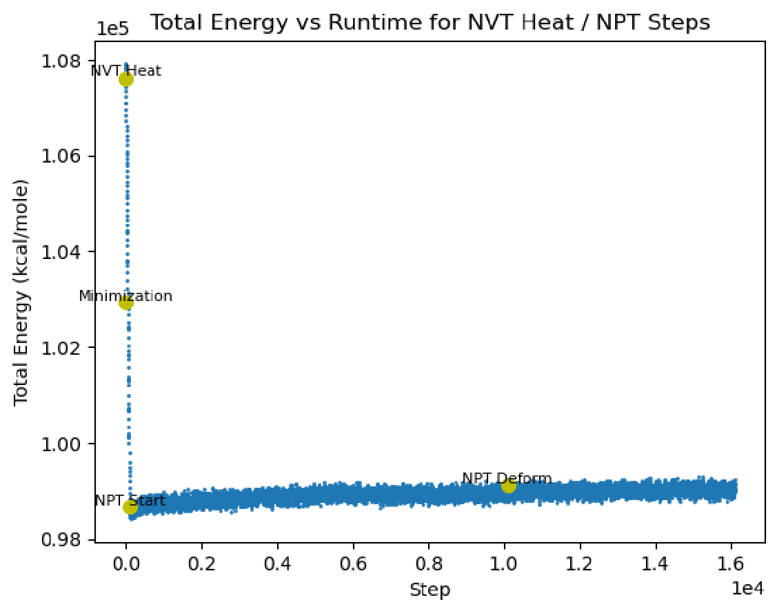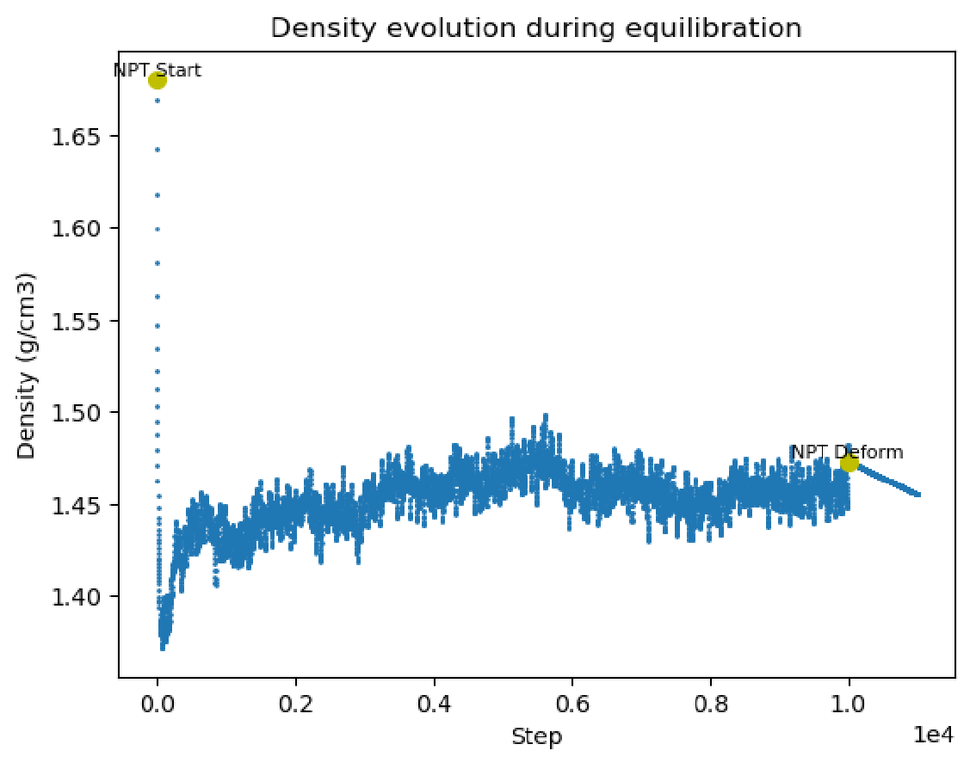
Figure 1: Equilibration of amorphous PVDF. a) Total energy convergence during equilibration: (i) conjugate-gradient minimization, (ii) 10 ps ramped NVT heating (1 K → 298 K), (iii) 1 ns NPT density relaxation, and (iv) 500 ps isothermal NVT. Plateaus in stages (iii) and (iv) confirm thermodynamic stability before DMA loading. b) Density evolution over same protocol: rapid densification occurs during early NPT, followed by fluctuations within ±0.5 % of the mean, indicating equilibration at 298 K. The final density (1.455 g cm⁻³) is underestimated relative to experiment, reflecting the fully amorphous morphology.
(b)
(a)
By fitting the sinusoidal pressure–strain response, we obtain the ellipsoidal stress–strain locus whose major-axis slope corresponds to the Young’s modulus in the elastic regime^{18,19}. For PVDF at 25 GHz with OPLS-AA (Fig. 2), DMAx yields $E_{Y}=1065$MPa; the experimental comparator is $1260$MPa²⁰.
We next assess glass-transition features. Fig. 3 shows storage modulus (SM), loss modulus (LM), and loss tangent (LT) for PVDF at 5 GHz using DMAx-optimized strain amplitude and runtime. Despite using a fully amorphous structure, the LT peak in the lower temperature regime deviates by < 10 °C from the experimental glass transition temperature²¹. Across the glass-transition regime, the temperature of the inflection/transition is consistent with experiment, while the absolute magnitudes of SM and LM differ from reported values.
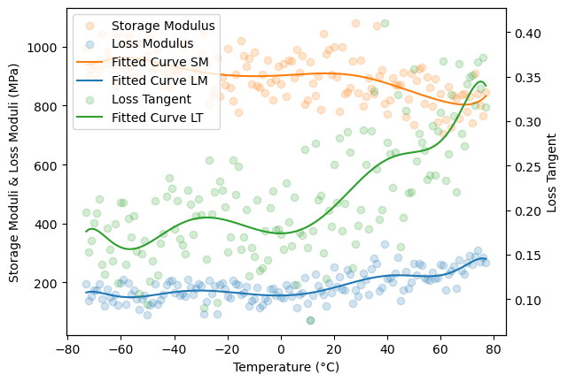
Figure 3: Viscoelastic spectra of PVDF near $T_{g}$ at 5 GHz. Overlaid storage modulus (SM), loss modulus (LM), and loss tangent (LT) highlight the simultaneous drop in stiffness and rise in damping as PVDF crosses $T_{g}$. The LT peak at approximately -30 °C is consistent with mechanical-loss signatures of experimental PVDF analyses.
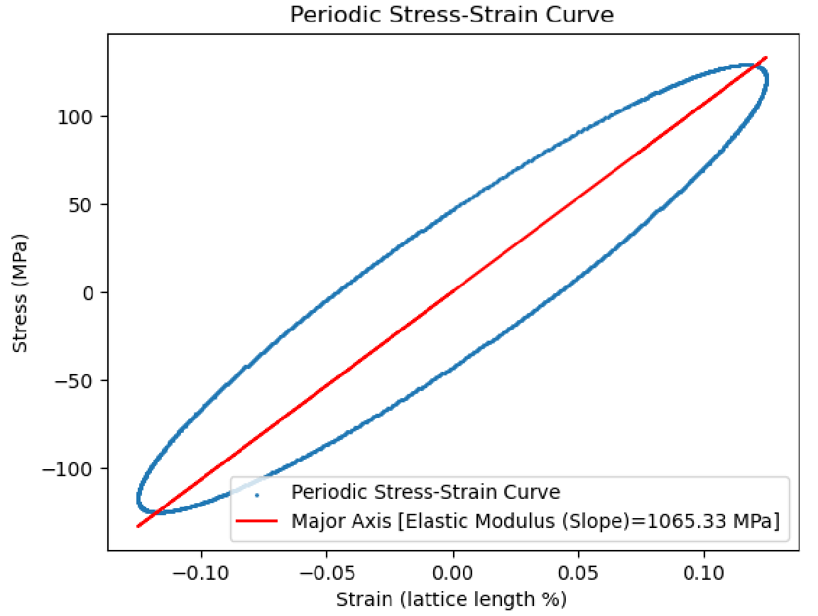

Figure 2: Stress–strain ellipse for PVDF at 25 GHz. The major-axis slope (1.06 GPa) gives the Young’s modulus, matching amorphous PVDF experiments within 15 %. The 21° phase lag, reflected in the ellipse tilt, quantifies viscoelastic energy dissipation at high frequency.
Master-curve construction used 100 simulations spanning 10–100 GHz and −70 °C to 20 °C, centered on the expected $T_{g}$region (Fig. 4). SM remains approximately constant over most of the simulated frequency range, while LM and LT increase as oscillation period decreases. At the highest frequencies, SM exhibits a monotonic decrease.
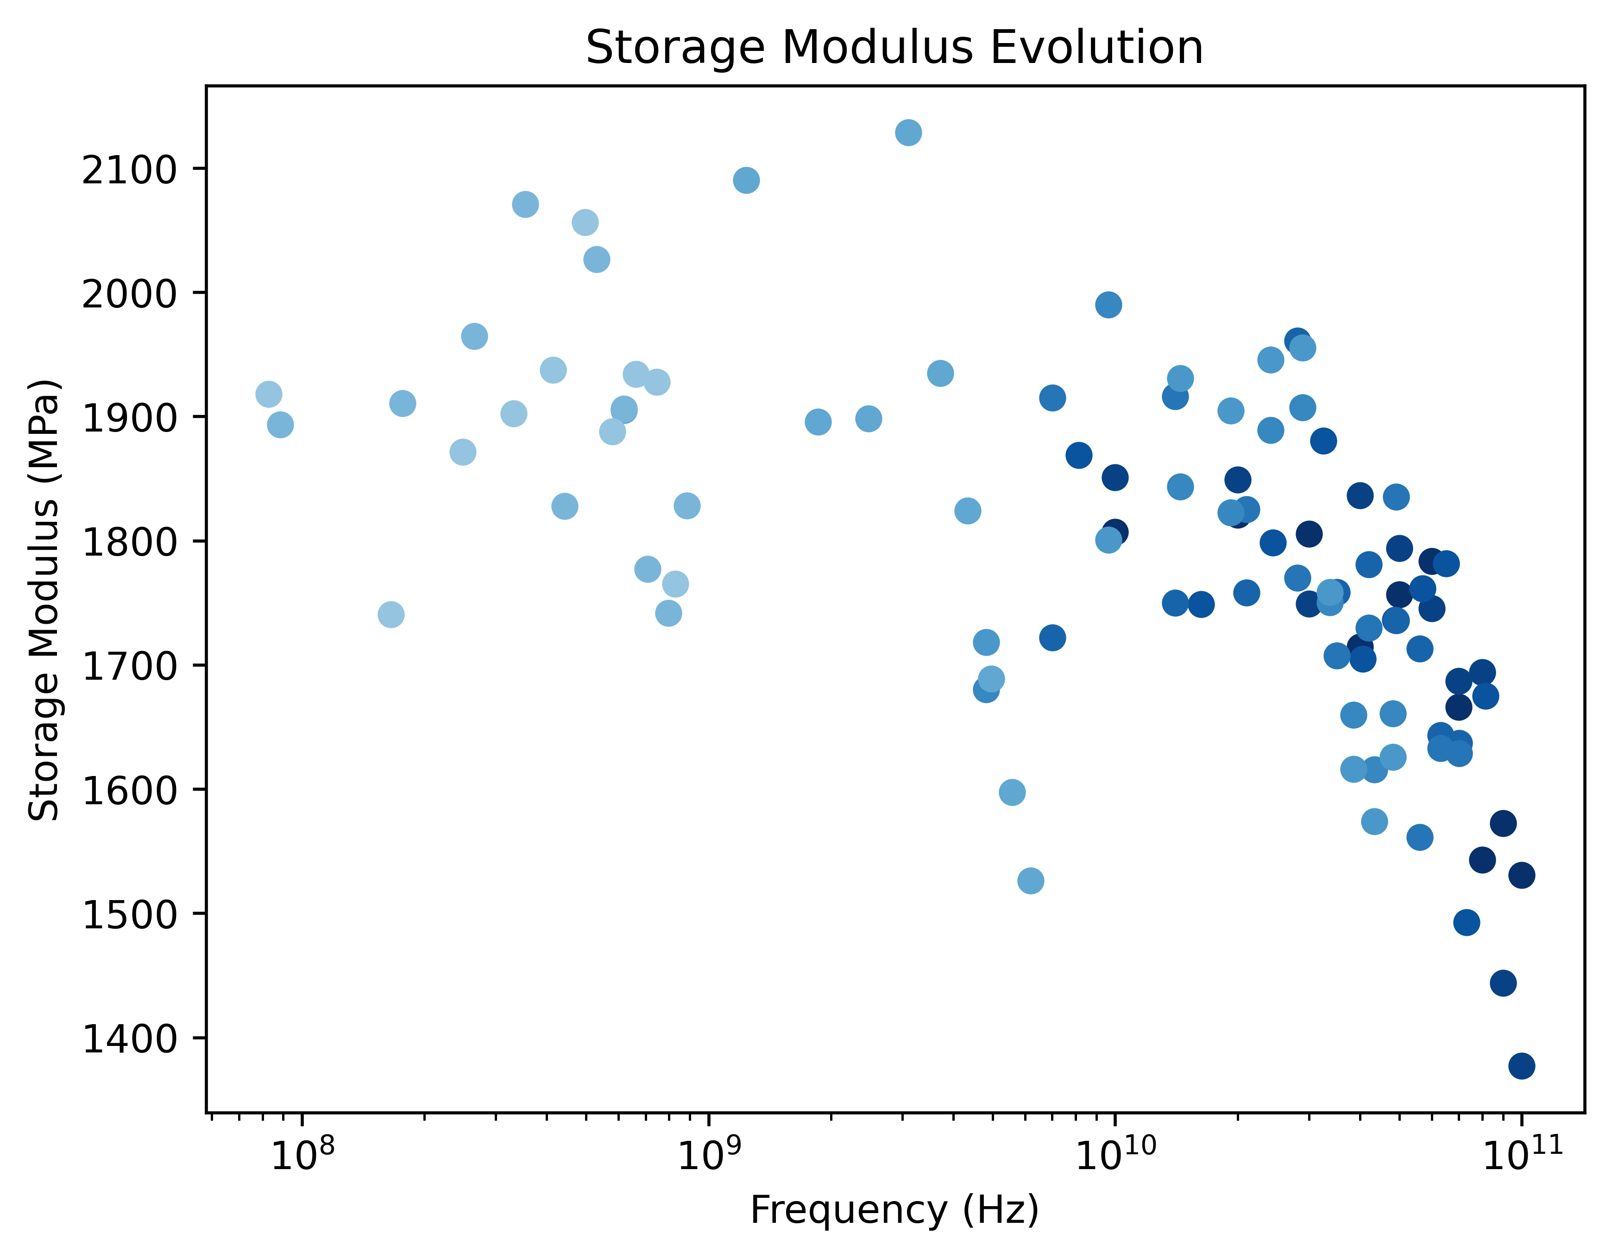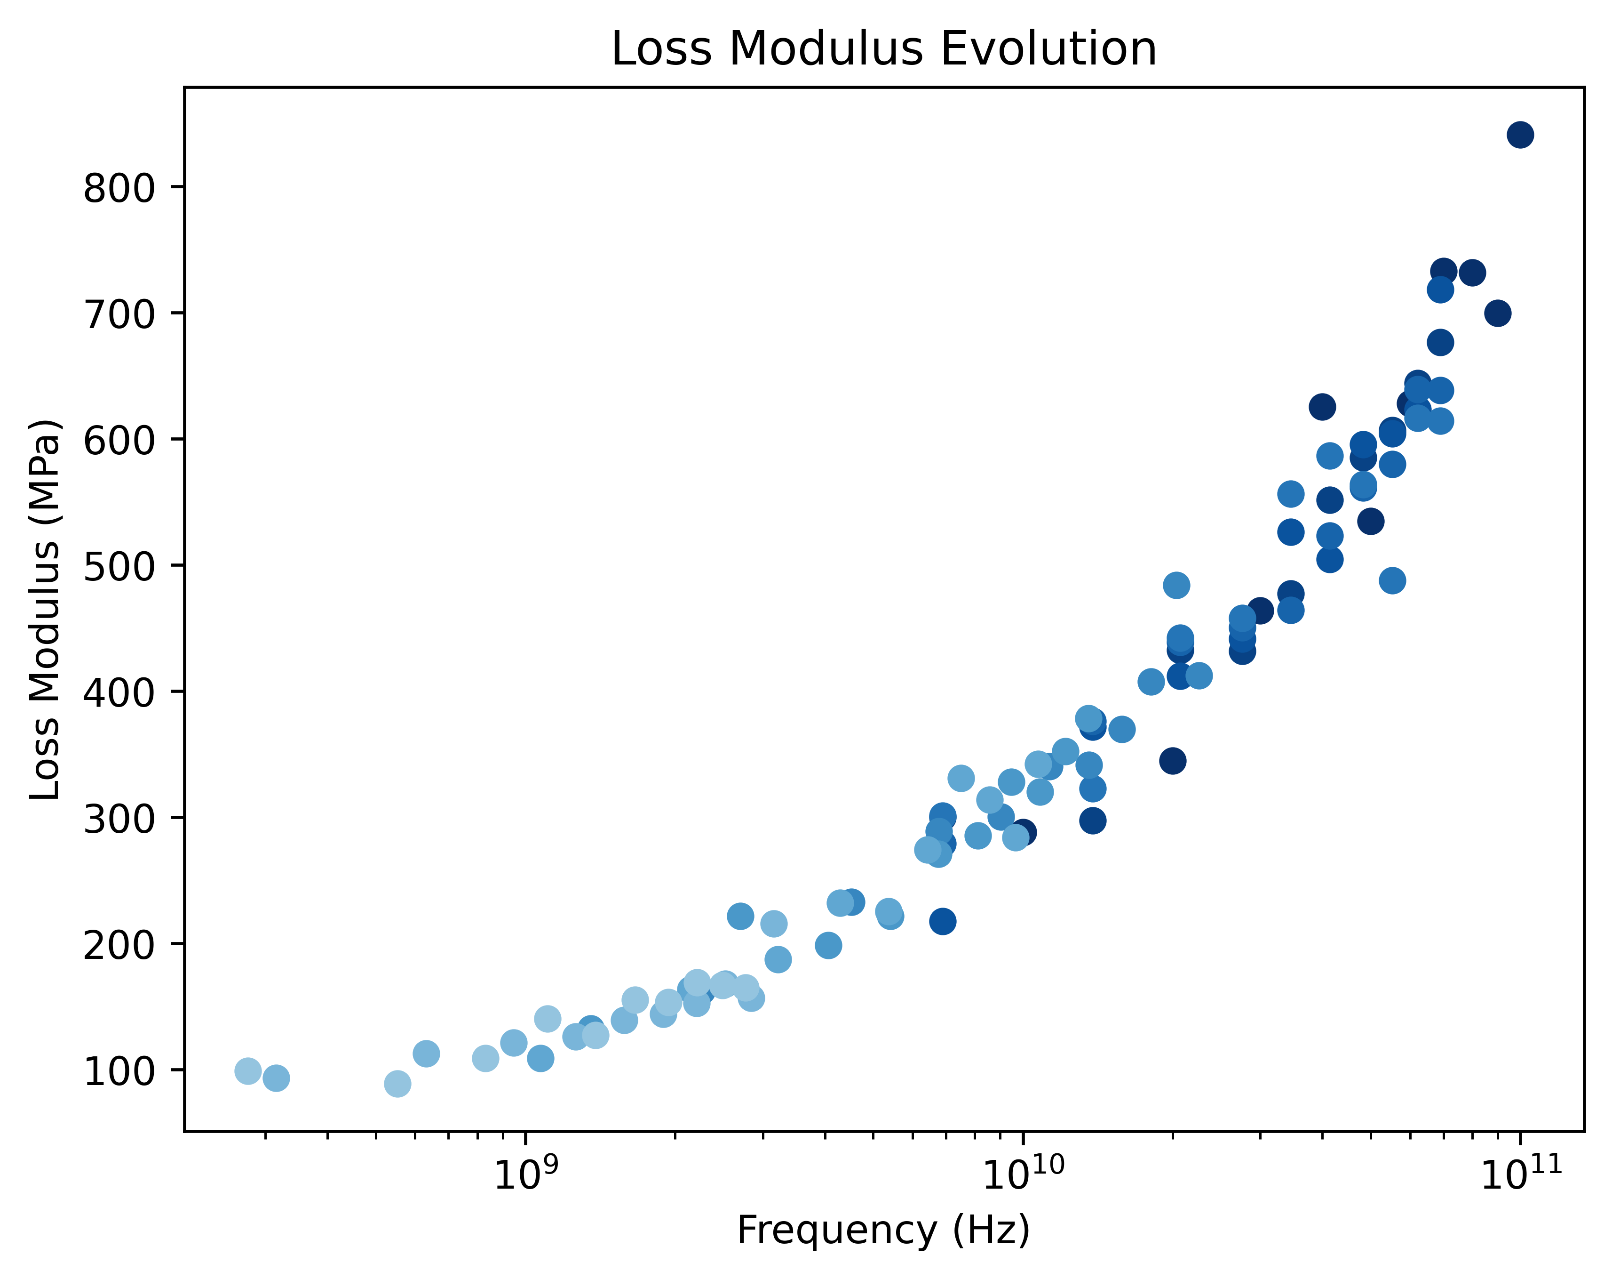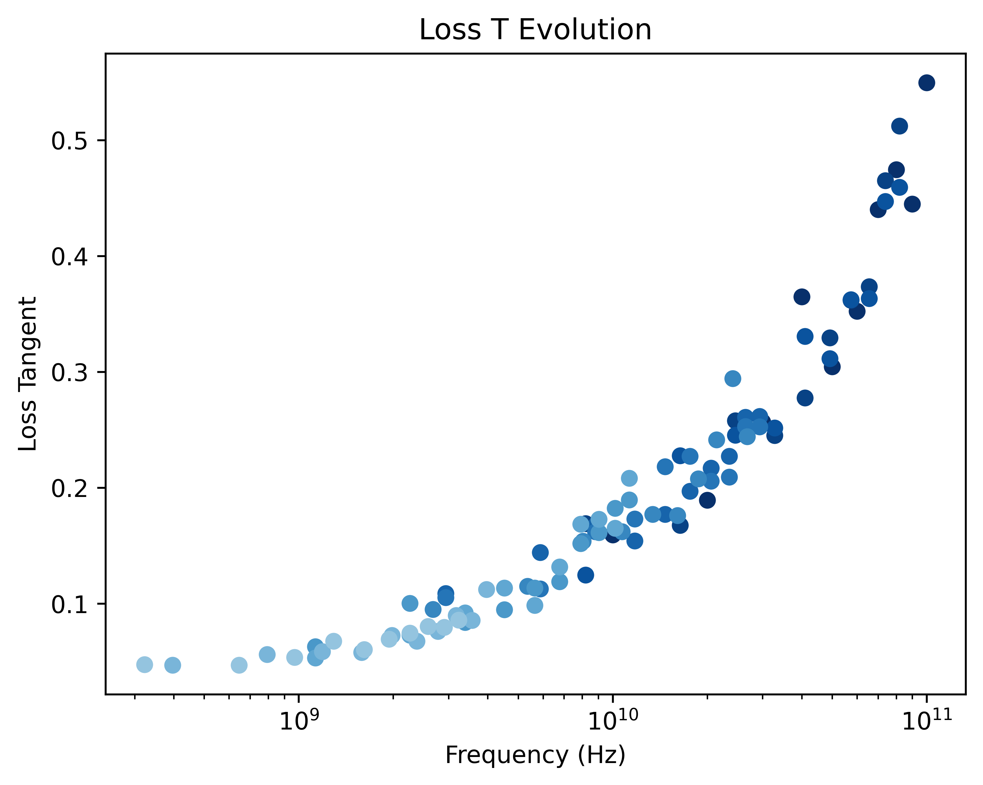
Figure 4: Master curve for storage modulus of PVDF (reference T = −25 °C). a) Storage Modulus. b) Loss Modulus. c) Loss Tangent. Gaussian process shifting of 100 simulations (10–100 GHz, −70 °C to 20 °C) collapses the data of each property into a single curve spanning nine decades in reduced frequency. Low-frequency extrapolation aligns with rheometry measurements, validating the TTS procedure. The loss tangent remains below 0.4 up to the MHz regime, then rises sharply in the GHz range, forecasting significant damping relevant for ultrasonic and RF applications. This trend complements storage-modulus stiffening, providing a complete viscoelastic profile across multiple frequency decades.
(a)
(b)
(c)

Discussion
The persistent underestimation of density relative to ≈ 1.455 g cm⁻³ likely reflects limitations in inter-chain van der Waals interactions in OPLS-AA and Byutner–Smith parameterizations for PVDF; an additional contributor is that experimental PVDF typically contains semicrystalline domains that raise bulk density relative to a purely amorphous model.
For the elastic response at 25 GHz, the $E_{Y}$ difference between simulation (1065 MPa) and experiment (1260 MPa) is ~15%—within the nominal uncertainty of our current DMAx analysis window and consistent with the broader trend that frequency-stiffening can shift apparent moduli depending on sampling and damping choices^{18–20}. Improving block-averaging, cycle counts, and uncertainty propagation should narrow this gap.
The glass-transition analysis highlights both strengths and limits of the present setup. Using a fully amorphous structure, we recover an LT peak within ~10 °C of crystalline PVDF benchmarks²¹, but the absolute SM/LM magnitudes diverge. These behaviors are expected if semicrystalline contributions are absent. A more rigorous protocol would simulate both amorphous and crystalline phases across the $T_{g}$ window and weigh their contributions to reflect realistic polymer dynamics; alternatively, generating semicrystalline cells with crystalline lamellae embedded in amorphous matrices would provide a closer comparator to experiment.
The master-curve trends (SM ~ constant; LM and LT increasing with frequency) match qualitative expectations for viscoelastic polymers in the probed window. The high-frequency decline in SM is likely a regime where the mechanical drive begins to couple with thermostat/barostat update intervals, yielding dynamics that are less representative of a canonical ensemble. More importantly, the lack of crystallinity likely degrades data quality below $T_{g}$, where semicrystalline morphology influences damping and modulus plateaus.
Two practical improvements follow. First, we will integrate semicrystalline-structure generation (e.g., workflows in the spirit of Belin et al.²²) and ensure crystalline cells are resized to be commensurate with the amorphous boxes used here. Second, we will employ Two-Phase Thermodynamics (2PT)²³ to build Gibbs free-energy curves and algorithmically identify temperature ranges for $T_{g}$ scans, mainly because 2PT’s reliance on short trajectories makes broader sampling feasible. Finally, we anticipate that adding machine-learned force fields will reduce noise in SM/LM/LT estimates and improve density and modulus fidelity across conditions.
Overall, DMAx reproduces key qualitative and quantitative features of PVDF’s viscoelastic response (including $T_{g}$ placement and the frequency dependence of LM/LT) while revealing clear paths to improve density accuracy, modulus agreement, and $T_{g}$-regime robustness through semicrystalline modeling, enhanced uncertainty treatment, and targeted ensemble controls.

Methods
Fully atomistic MD simulations were performed with the Large-scale Atomic/Molecular Massively Parallel Simulator (LAMMPS).^{24,25} We considered a purely amorphous Polyvinylidene Fluoride (PVDF) structure, built with in-house scripts, comprising 10 chains of 100 monomers (6080 atoms total) under periodic boundary conditions, with an initial density of 1.68 g/cm³ that closely matched experiments (Fig. 5).²⁶ Previous works described a comparable PVDF system using the forcefield of Byutner and Smith²⁷, however, we employed the Optimized Potential for Liquid Simulations (OPLS-AA)²⁸ in this study for computational convenience and transferability across a range of polymeric systems.
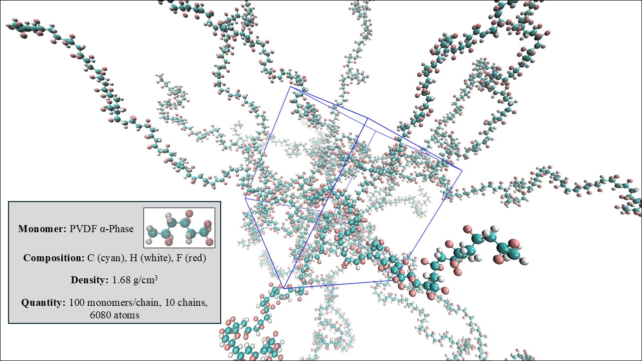
Figure 5: Amorphous PVDF simulation cell. The model comprises 10 chains of 100 monomers each (6080 atoms total), terminated and wrapped under periodic boundary conditions at an initial density of 1.68 g cm⁻³. Although alternative chain/monomer configurations yielded similar average properties, the longer-chain setup ensured proper molecular entanglement and reduced pressure noise, improving the reliability of dynamic mechanical property calculations.
With the appropriate input structure and DMA parameters, the DMAx object-oriented Python package enables straightforward calculation of storage modulus, loss modulus, and loss tangent at user-specified temperatures, pressures, and frequencies for a parametrized material. To extend this capability to high-throughput screening of multiple polymers and detailed property evaluation—including Young’s modulus, glass transition temperature, and master curves—we developed a sequential workflow requiring minimal user intervention (Fig. 6). DMAx leverages the atomate2 package²⁹ to automate the execution and management of tasks.
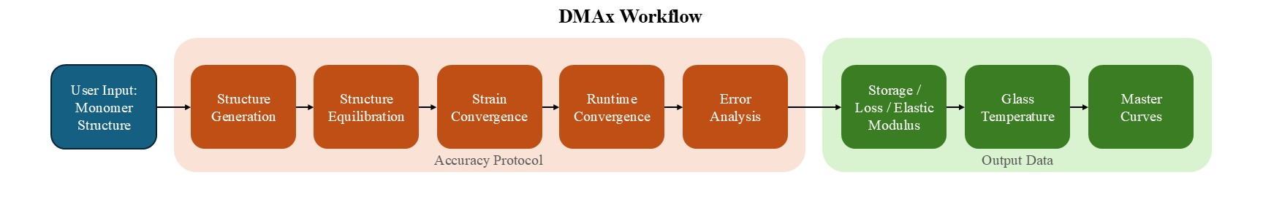
Figure 6: DMAx workflow. Automated computational framework for extracting polymer mechanical properties. Standard parameters—strain amplitude, runtime for convergence, and ranges of frequency and temperature—are determined self-consistently, enabling calculation of glass transition temperature, storage and loss moduli, and master curves.

Input Selection & Structure Optimization
We provide multiple options for generating polymer systems in DMAx. For simpler cases, the workflow integrates with the PolymerStructurePredictor package of Sahu et al.³⁰ Here, users simply supply a SMILES string of the target monomer. Alternatively, users can provide atomic structures in MSI Biograf (.bgf), Sybyl (.mol2) or Protein Data Bank (.pdb) formats. Our in-house scripts parse these files to generate the corresponding LAMMPS input and data files. Additional formats such as CIFs and POSCAR (VASP), are also supported; however, because they lack explicit bonding information, bonds are inferred during preprocessing. Finally, users can directly supply pre-generated LAMMPS data files for use throughout the workflow. These advanced input options broaden the scope of systems accessible to DMAx, including polymers with impurities or mixed-chain compositions, and improve accuracy by enabling the use of tailored force fields, including machine-learned interatomic potentials. Once the structures have been inputted, the workflow constructs crystalline and amorphous structures before equilibrating them via MD simulations in LAMMPS. Parameters such as density, monomer count, and number of chains can be set explicitly or determined automatically based on heuristics derived from prior successful simulations.
By default, DMAx employs the OPLS-AA force field when no alternative is specified. OPLS-AA has demonstrated good agreement with experimental data across a range of polymeric and organic systems,²⁸ capturing conformational energies, bond lengths, dihedral distributions, and phase behavior. Importantly, its balanced treatment of bonded and nonbonded interactions enables accurate modeling of structural and dynamical responses of polymers under periodic strain.
Each MD simulation in the workflow can subject the polymer to an equilibration sequence prior to dynamic mechanical analysis. For a full workflow run, this equilibration is performed once, and the equilibrated structure is saved and reused in subsequent steps to reduce computational cost. The protocol consists of a 500-step conjugate-gradient minimization, followed by a 10 ps heating ramp from 1 K to the target temperature under a Nosé–Hoover thermostat (NVT). While equilibration is often performed directly at the analysis temperature, we employ this ramping procedure to avoid unstable dynamics that can arise when assigning high velocities to an unrelaxed configuration. The system is then equilibrated for 1 ns under a Nosé–Hoover barostat (NPT) to achieve the correct density. Lattice parameters are averaged from the NPT step, and a final 500 ps NVT run is performed to equilibrate the new density at the target temperature. After equilibration, simulations evolve under an NVT ensemble to control temperature—analogous to the heat chamber in a rheometer—while the system is sinusoidally deformed at user-defined amplitude, temperature, pressure, and frequency. At present, DMAx supports tensile/compressive and shear analyses; future releases will include additional perturbation modes such as purely tensile, purely compressive, and cantilever deformations, among others.
The oscillatory protocol in DMAx differs somewhat from experiments: simulations impose a prescribed strain and measure the resulting stress, whereas experiments typically apply stress and record strain. Since the relevant quantity is the phase lag between stress and strain, the choice of input and output signal does not affect property determination. Mechanical properties are extracted from the MD trajectory by fitting a sinusoidal function to the pressure output using the SciPy package and measuring the phase angle relative to the applied strain. Although the Nyquist–Shannon theorem³¹ requires a sampling rate at least twice the maximum signal frequency, DMAx records 1000 data points per oscillation cycle by default, balancing fitting accuracy with computational efficiency.
We find that maintaining a system size of ~6000 atoms ensure reliable stress data. Storage and loss moduli are obtained by averaging the pressure response during simulations, where pressure is a statistical quantity computed from momentum exchange between particles.³² Small systems suffer from larger fluctuations due to limited particle sampling and high surface-to-volume ratios, which amplify noise in the stress signal. Larger systems reduce these artifacts, motivating the established atom-count threshold. Additionally, given that the pressure output is a rank 2 tensor, for compression/tension modes, the pressure component parallel to the strain direction is analyzed, whereas for shear modes the orthogonal component is used. In compression/tension simulations, cell dimensions are adjusted in the perpendicular directions as the strained axis expands or contracts, ensuring constant volume and more faithful reproduction of experimental conditions.

Strain Size Convergence
There is no clear consensus in the literature on the appropriate strain amplitude for simulating DMA; guidelines only recommend that it remain within the linear viscoelastic regime. Thus we implemented an automated strain size criteria in DMAx, which therefore identifies the onset of plastic deformation and defines the maximum allowable strain, paralleling standard practice in experimental DMA³³. A further consideration is the trade-off between accuracy and computational cost under sinusoidal perturbation. The thermostat, when coupled with oscillatory deformation, introduces pressure fluctuations³⁴ that dominate the stress signal at very small strains, producing unfilterable noise. This effect is particularly pronounced in amorphous polymers, where van der Waals interactions provide weaker restoring forces than the directional covalent bonds in crystalline systems. As a result, the true stress response can be obscured by thermostat-induced noise at low amplitudes, whereas at high amplitudes nonlinear drift emerges. This behavior is illustrated for the amorphous PVDF structure in Fig. 7a,b.
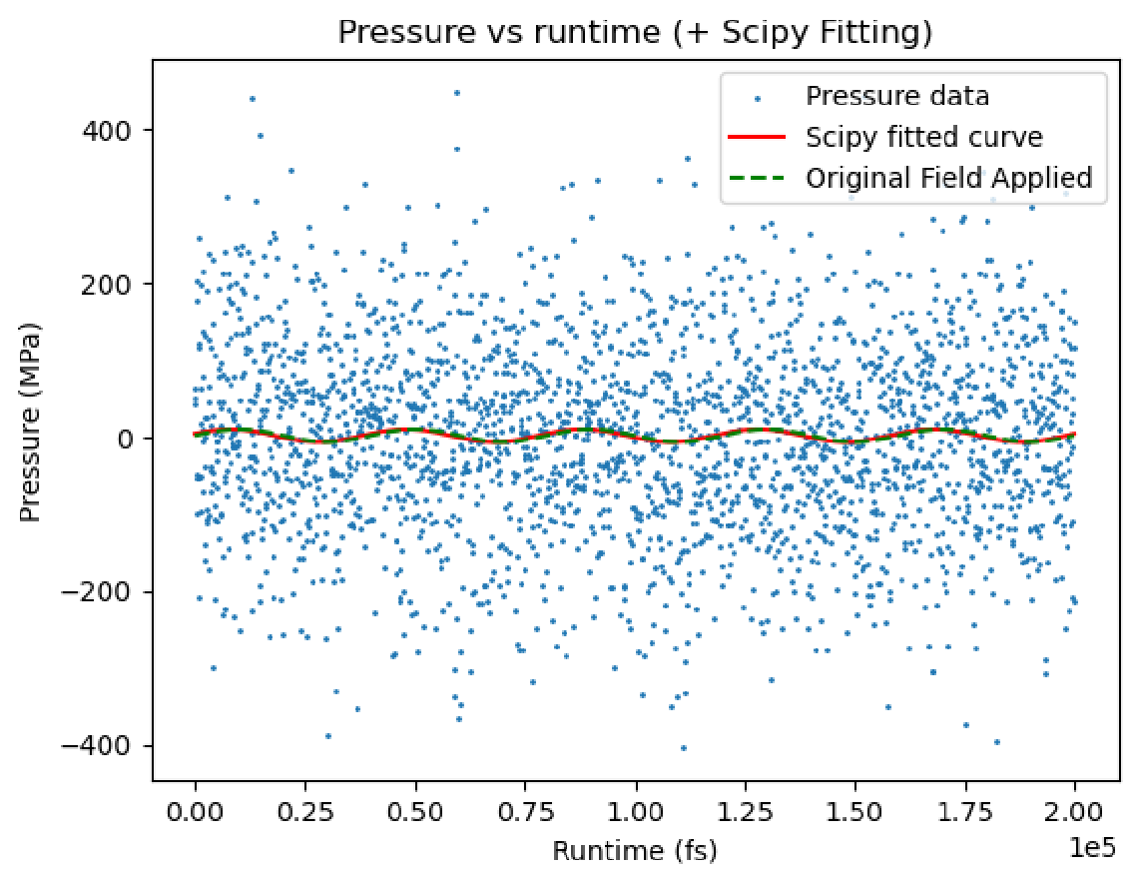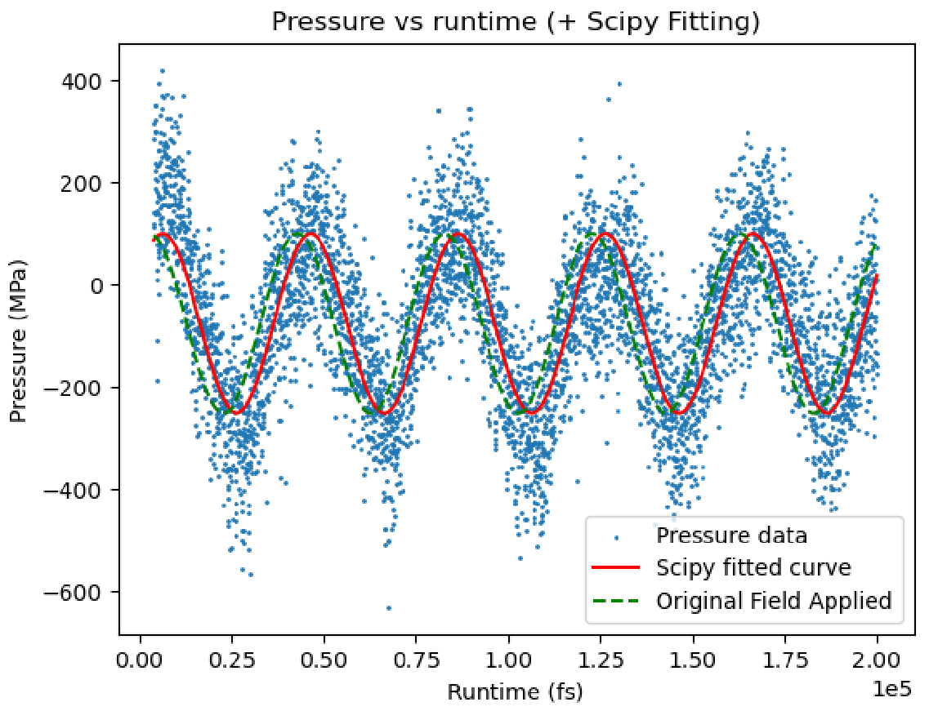
Figure 7: Strain-amplitude dependence of stress response in amorphous PVDF (10 GHz). a) At 1 % strain, thermostat-induced pressure noise dominates the signal, producing poor sinusoidal fits (R² < 0.1) and underscoring the need for amplitude optimization beyond the “small-strain” assumption. b) At 23 % strain, a clean sinusoid appears, but a −120 MPa DC offset indicates systematic drift as the system leaves the linear viscoelastic regime. Optimal amplitudes therefore lie between these extremes.
(a)
(b)
As noted above, noise can be reduced by enlarging the simulation cell, but this approach substantially increases computational cost. Instead, DMAx mitigates noise by identifying an optimal strain amplitude that minimizes a statistical cost function, in addition to defining the maximum strain within the linear viscoelastic regime. This strategy also helps align computational strain values with experimental practice, where strains are typically much smaller for both crystalline and amorphous systems.
For convergence analysis, each structure undergoes 10 DMA cycles across a range of strain amplitudes: 0.1–50 % for amorphous systems and 0.001–10 % for crystalline systems, relative to the unit cell length. The various viscoelastic properties are then evaluated, as well as the root-mean-squared error (RMSE), R² score, and pressure offset from the sinusoidal fit. Strains are ranked by lowest RMSE and offset and highest R², and the best-performing amplitude is selected for subsequent workflow steps. An example for PVDF is shown in Fig. 8, where our workflow identifies ~8 % strain as optimal—lower than the ~12 % suggested in Ghajar et al.¹⁷—owing to the negative pressure offset at higher amplitudes, which indicates drift and the onset of nonlinearity.
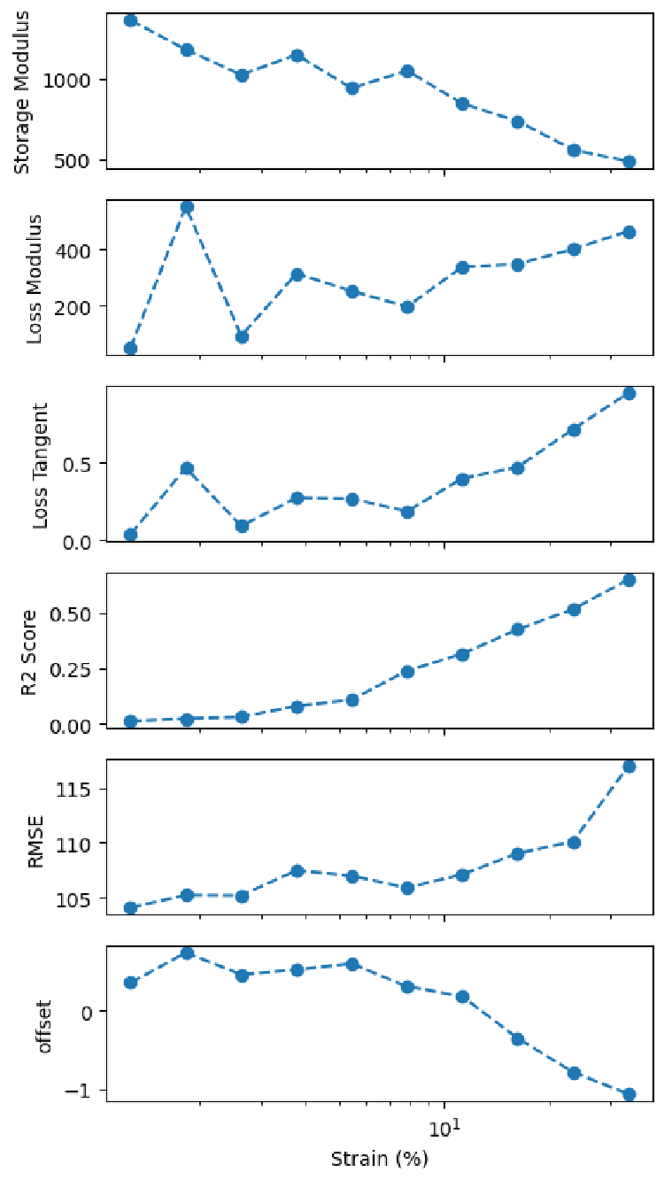
Figure 8: Amplitude-selection map for PVDF. Storage modulus, loss modulus, and loss tangent remain nearly constant around 8 % strain, while RMSE is minimized and R² maximized. The composite score (right axis) identifies 8 % as the globally optimal strain, balancing noise suppression against nonlinear drift.

Number of Cycles Convergence
This convergence step is designed to reduce computational cost while maintaining accuracy, enabling high-throughput analysis. In the previous stage, 10 complete DMA cycles were run and fit with a sinusoidal curve. In practice, however, far fewer cycles—particularly for crystalline structures—are often sufficient to achieve a reliable fit. Moreover, although the simulations are performed in the elastic regime, continuous oscillations can subtly alter the hysteresis response in both experimental and computational settings.
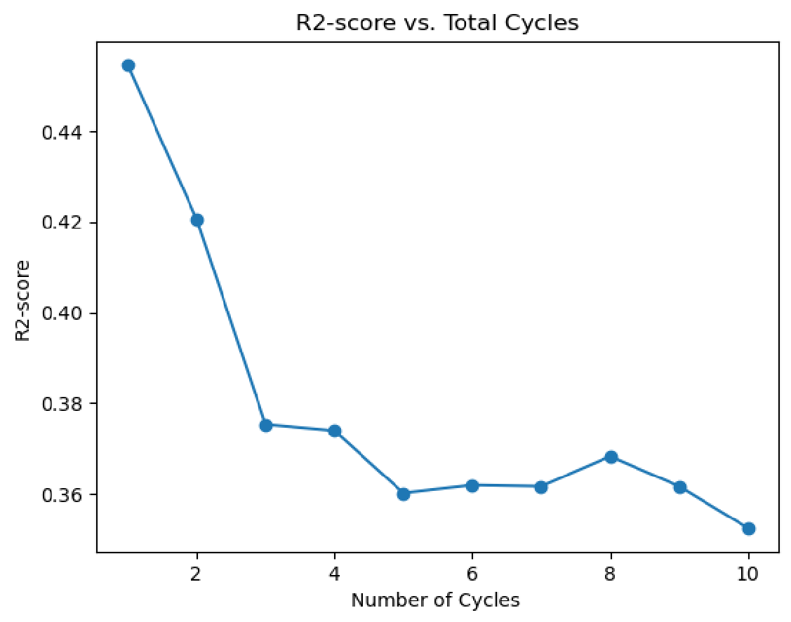
Figure 9: Cycle-count convergence for PVDF (8 % strain, 10 GHz). R² increases sharply from one to four cycles and then plateaus within 1 %. DMAx therefore truncates production runs to four cycles, reducing wall time by ~60 % relative to legacy 10-cycle protocols without compromising fit quality.
To quantify this, the 10-cycle trajectory at the optimal strain is subdivided into segments containing 1 through 10 cycles. R² is then evaluated for each segment, and convergence is defined when the variation between consecutive cycle counts falls below 1 %. An example for PVDF is shown in Fig. 9, where the workflow identifies four cycles as sufficient at 8 % strain.

Error Quantification
This stage of the workflow, like those that follow, extends beyond prior reports of cyclic mechanical property analysis with MD. It leverages the optimized strain amplitude and cycle count to quantify the statistical uncertainty of simulations under these conditions. For example, error analysis reinitializes each oscillation with a different Maxwell–Boltzmann velocity distribution at the target temperature (298 K unless otherwise specified). These randomized velocity seeds provide independent dynamical trajectories from the same equilibrated structure. Because the structure has already been optimized and equilibrated, we assume that any velocity distribution will converge to physically meaningful dynamics.
Errors can be evaluated at multiple frequencies, with a default analysis at 25 GHz and ten independent replicas per frequency. Fig. 10a,b illustrates that error magnitude is essentially frequency-independent: for a 6,080-atom system (9a), 20 replicas at 10–25 GHz yield uncertainties in storage, loss, and tangent moduli of ±10–15 %. Instead, the dominant factor is system size. In the larger 19,216-atom cell (9b), the variance of the moduli is reduced by roughly half, consistent with the statistical scaling of equilibrium fluctuations. Specifically, pressure fluctuations—and thus fitting error—scale as $1/\sqrt{N}$ ​, where $N$ is the number of atoms. This reflects the improved averaging of microscopic fluctuations in larger systems, albeit at the cost of significantly increased computational time.
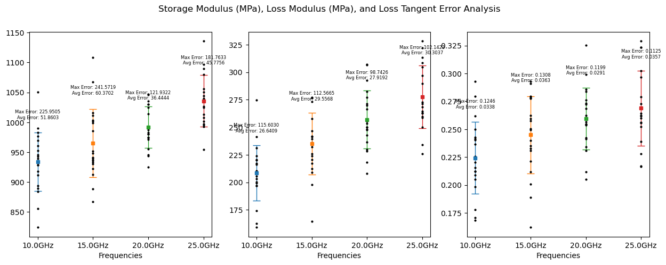
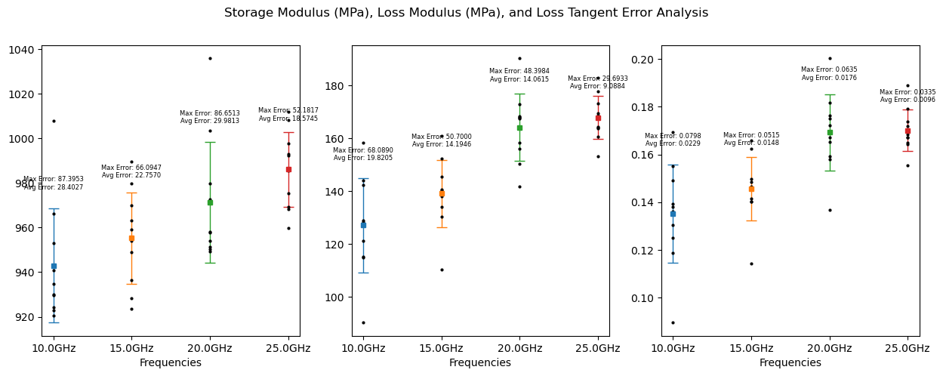
Figure 10: Error analysis for amorphous PVDF. a) Uncertainty range for a 6,080-atom cell. Twenty replicas at four frequencies (10–25 GHz) show that scatter in storage, loss, and tangent moduli is frequency-independent but sizable (±10–15 %). Error bars denote one standard deviation across velocity seeds. b) System-size effect on uncertainty (19,216 atoms). Tripling the atom count reduces modulus scatter by half, consistent with pressure fluctuations—and thus fitting error—scaling inversely with system size. The ~3× increase in computational cost highlights the trade-off between precision and throughput.
As in all other steps of the workflow, during error analysis, any simulation with an R² score lower than 0.01 is eliminated from the plot since the noise prevents the capture of a well-defined sinusoidal behavior, thus making the data unreliable.

Glass Temperature Analysis
The glass transition temperature (T_{g}) is a critical thermodynamic property of amorphous polymers, marking the transition from a rigid, glassy state to a more flexible, rubbery state. Below T_{g}, polymers exhibit restricted molecular motion and high stiffness, while above T_{g}, increased mobility leads to enhanced flexibility.³⁵ Factors such as molecular weight, chain flexibility, chemical structure, and processing conditions strongly influence T_{g}. Accurate determination of T_{g} is essential for tailoring polymer performance across diverse applications, from material design to processing and end-use stability³⁶.
Conventional approaches determine T_{g} by equilibrating system volume under an NPT ensemble at multiple temperatures—a procedure that is computationally expensive and time-intensive.³⁷. In contrast, in DMAx we propose the first implementation of the glass transition analysis method. We assume that a single equilibration at room temperature is sufficient, provided velocities are reassigned at each oscillatory run to match the target temperature. Because higher frequencies correspond to shorter oscillation periods, this approach significantly reduces runtime compared to the NPT ensemble.

Master Curve
Master curves (MCs) are central to polymer characterization, providing a means to extrapolate mechanical behavior under conditions that may be impractical to probe experimentally. The construction of MCs often relies on the time–temperature superposition (TTS) principle, which assumes that mechanical responses measured at different temperatures can be shifted along the frequency or time axis and superimposed into a single continuous curve. Through this procedure, viscoelastic data measured over limited frequency or time windows can be unified into a master curve spanning several orders of magnitude for a reference temperature.
To generate the Master Curve, the storage modulus (E′) is plotted against frequency (i.e., time) over a series of isotherms. Each isotherm is assigned a shift factor $α_{T}$ relative to a reference temperature ($T_{ref}$). These factors can be obtained either through computational curve fitting or using the experimental Williams–Landel–Ferry (WLF) relation (Equation 2):
$\log{α_{T}}=\frac{-c_{1}(T-T_{ref})}{c_{2}(T-T_{ref})}$ (2)

The WLF method requires two material-specific constants, $c_{1}$ and $c_{2}$, which are not always available for the polymer of interest. Thus in DMAx, besides using reference $c_{1}$ and $c_{2}$ values, we also have an alternative to obtain the master curve by means of a curve-fitting approach using the mastercurves Python package developed by Lennon et al.³⁸ This software employs Gaussian process regression to determine the shift factors and generate a continuous curve referenced to the chosen temperature. The resulting interpolant, with associated uncertainty bounds, provides both vertical and horizontal shifts for each isotherm, ensuring maximal continuity of the master curve. The final curve thus represents the material’s mechanical response at the reference temperature—typically near T_{g}—across a much broader frequency range.

Data availability
The structure seeds used in this study—the .bgf files for the 6,080-atom and 19,216-atom PVDF systems—are provided in the project’s GitHub repository under https://github.com/atlas-nano/atomate2_dmax/tree/feature/dmax2-lammps/src/atomate2/dmax/paper_structures. Due to storage and bandwidth constraints, the complete LAMMPS trajectory files generated in this work are not deposited; however, these input structures, together with the workflow instructions described in the Methods section and in the repository documentation, are sufficient to reproduce all results reported in this work.

Code availability
This work uses a fork of the atomate2 codebase that incorporates the DMAx workflow and supporting scripts. The fork is openly available at https://github.com/atlas-nano/atomate2_dmax. As the additional features outlined in the Discussion (e.g., semicrystalline structure generation, automated $T_{g}$window identification, and optional MLFF support) are implemented and stabilized, our goal is to upstream these capabilities and request a merge into the main atomate2 repository.

Acknowledgements
This research used resources of the National Energy Research Scientific Computing Center (NERSC), a U.S. Department of Energy Office of Science User Facility operated under Contract No. DE-AC02-05CH11231. This work used compute hours from NERSC ERCAP project m4537.

Funding
T. A. P. discloses support for the research of this work from the National Science Foundation, UCSD MRSEC DMR-2011924, and the use of facilities and instrumentation supported by the National Science Foundation through UCSD MRSEC DMR-201192.

Author Contributions
T.A.P. conceived the idea and supervised the project. R.S.B. created the workflow, performed the simulations and analyzed the data. B.F. assisted in designing the workflow and running the simulations. S.J. assisted in designing the simulations. The manuscript was written by R.S.B. and T.A.P., with comments and consent from all authors.

Competing Interests
The authors declare no competing interests.
References
1. Rochman, C. M. Plastics and priority pollutants: A multiple stressor in aquatic habitats. Polymer 107, 27–34 (2016).
2. Patra, S., Ajayan, P. M. & Narayanan, T. N. Dynamic mechanical analysis in materials science: The Novice’s Tale. Oxf. Open Mater. Sci. 1, itaa001 (2020).
3. Jones, D. Dynamic mechanical analysis of polymeric systems of pharmaceutical and biomedical significance. Int. J. Pharm. 179, 167–178 (1999).
4. Schalnat, J. et al. Influencing parameters on measurement accuracy in dynamic mechanical analysis of thermoplastic polymers and their composites. Polym. Test. 91, 106799 (2020).
5. Oregui, M., de Man, A., Woldekidan, M. F., Li, Z. & Dollevoet, R. Obtaining railpad properties via dynamic mechanical analysis. J. Sound Vib. 363, 460–472 (2016).
6. Huebsch, N. et al. Ultrasound-triggered disruption and self-healing of reversibly cross-linked hydrogels for drug delivery and enhanced chemotherapy. Proc. Natl. Acad. Sci. 111, 9762–9767 (2014).
7. Lionetto, F., Montagna, F. & Maffezzoli, A. Ultrasonic dynamic mechanical analysis of polymers. Appl. Rheol. 15, 326–335 (2005).
8. O’Connell, P. A. & McKenna, G. B. Arrhenius-type temperature dependence of the segmental relaxation below Tg. J. Chem. Phys. 110, 11054–11060 (1999).
9. Barsoum, S. & Zinkle, T. Fundamental principles of mechanical behavior. Mater. Sci. Eng. A 276, 1–4 (1999).
10. Shangguan, Y. et al. New Insight into Time-Temperature Correlation for Polymer Relaxations Ranging from Secondary Relaxation to Terminal Flow: Application of a Universal and Developed WLF Equation. Polymers 9, 567 (2017).
11. Afzal, M. A. & et al. High-throughput molecular dynamics simulations and validation of thermophysical properties of polymers for various applications. ACS Appl. Polym. Mater. 3, 620–630 (2020).
12. Pinheiro, A. & Mano, J. F. Study of the glass transition on viscous-forming and powder materials using dynamic mechanical analysis. Polym. Test. 28, 89–95 (2009).
13. Han, J., Gee, R. H. & Boyd, R. H. Glass transition temperatures of polymers from molecular dynamics simulations. Macromolecules 27, 7781–7784 (1994).
14. Chantawansri, T. L., Yeh, I.-C. & Hsieh, A. J. Investigating the glass transition temperature at the atom-level in select model polyamides: A molecular dynamics study. Polymer 81, 50–61 (2015).
15. Patrone, P. N., Dienstfrey, A., Browning, A. R., Tucker, S. & Christensen, S. Uncertainty quantification in molecular dynamics studies of the glass transition temperature. Polymer 87, 246–259 (2016).
16. Guseva, D. V. & et al. Dynamic and static mechanical properties of crosslinked polymer matrices: Multiscale simulations and experiments. Polymers 10, 792 (2018).
17. Ghajar, M. H., Mosavi Mashhadi, M. & Ghattan Kashani, H. Dynamic mechanical analysis of Bucky Gel actuator electrolyte by molecular dynamics simulation. Comput. Mater. Sci. 149, 379–385 (2018).
18. Duncan, J. C. & Price, D. M. Thermomechanical, dynamic mechanical and dielectric methods. in Principles of Thermal Analysis and Calorimetry 164–213 (2016). doi:10.1039/BK9781782620518-00164.
19. Menard, K. P. & Menard, N. R. Dynamic Mechanical Analysis. (2020). doi:10.1201/9780429190308.
20. Mandal, A. & Nandi, A. K. Physical properties of poly(vinylidene fluoride) composites with polymer functionalized multiwalled carbon nanotubes using nitrene chemistry. J. Mater. Chem. 21, 15752 (2011).
21. Zhu, W., Ma, J., Nan, X., Osei Lartey, P. & Yang, Y. Study on dispersion of reduced graphene oxide on physical performance of polyvinylidene fluoride composites by Hansen solubility parameters. Colloid Polym. Sci. 297, 213–224 (2019).
22. Belin, B., Yiannourakou, M., Lachet, V. & Rousseau, B. Modeling method for semicrystalline polymers controlling aspects of the morphology at the molecular scale for the study of mechanical and physicochemical properties. J. Phys. Chem. B 126, 9673–9685 (2022).
23. Lin, S.-T., Maiti, P. K. & Goddard, W. A. Two-phase thermodynamic model for efficient and accurate absolute entropy of water from molecular dynamics simulations. J. Phys. Chem. B 114, 8191–8198 (2010).
24. Plimpton, S. Fast Parallel Algorithms for Short-Range Molecular Dynamics. J. Comput. Phys. 117, 1–19 (1995).
25. Thompson, A. P. et al. LAMMPS - a flexible simulation tool for particle-based materials modeling at the atomic, meso, and continuum scales. Comput. Phys. Commun. 271, 108171 (2022).
26. Meng, N. & et al. Ultrahigh β-phase content poly(vinylidene fluoride) with relaxor-like ferroelectricity for high energy density capacitors. Nat. Commun. 10, (2019).
27. Byutner, O. G. & Smith, G. D. Quantum chemistry based force field for simulations of poly(vinylidene fluoride). Macromolecules 33, 4264–4270 (2000).
28. Jorgensen, W. L., Maxwell, D. S. & Tirado-Rives, J. Development and testing of the OPLS all-atom force field on conformational energetics and properties of organic liquids. J. Am. Chem. Soc. 118, 11225–11236 (1996).
29. Ganose, A. M. et al. Atomate2: modular workflows for materials science. Digit. Discov. 4, 1944–1973 (2025).
30. Sahu, H., Shen, K.-H., Montoya, J. H., Tran, H. & Ramprasad, R. Polymer structure predictor (PSP): A python toolkit for predicting atomic-level structural models for a range of polymer geometries. J. Chem. Theory Comput. 18, 2737–2748 (2022).
31. Farrow, C. L., Shaw, M., Kim, H., Juhás, P. & Billinge, S. J. Nyquist-Shannon sampling theorem applied to refinements of the atomic pair distribution function. Phys. Rev. B 84, (2011).
32. Thompson, A. P., Plimpton, S. J. & Mattson, W. General formulation of pressure and stress tensor for arbitrary many-body interaction potentials under periodic boundary conditions. J. Chem. Phys. 131, (2009).
33. Starkova, O. & Aniskevich, A. Limits of linear viscoelastic behavior of polymers. Mech. Time-Depend. Mater. 11, 111–126 (2007).
34. Feller, S. E., Zhang, Y., Pastor, R. W. & Brooks, B. R. Constant pressure molecular dynamics simulation: The Langevin piston method. J. Chem. Phys. 103, 4613–4621 (1995).
35. Fox, T. G. & Flory, P. J. The glass temperature and related properties of polystyrene. influence of molecular weight. J. Polym. Sci. 14, 315–319 (1954).
36. Bhandari, B. R. & Howes, T. Implication of glass transition for the drying and stability of dried foods. J. Food Eng. 40, 71–79 (1999).
37. Minelli, M., De Angelis, M. G. & Hofmann, D. A novel multiscale method for the prediction of the volumetric and gas solubility behavior of high-TG polyimides. Fluid Phase Equilibria 333, 87–96 (2012).
38. Lennon, K. R., McKinley, G. H. & Swan, J. W. A data-driven method for automated data superposition with applications in soft matter science. Data-Centric Eng. 4, (2023).

